Document Submission
To make sure that all requests for new diplomas and changes to diplomas are processed promptly we are now mandating the submission of documents and forms through the Open Awards Secure Portal.
Submitting a document is really easy. Just log onto the portal and click on the Resources option in the menu bar then Documents from the drop-down list.
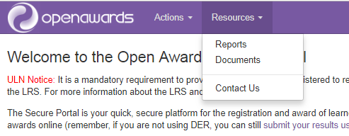
In the Documents page choose ‘Access to HE’ from the –Document Type- drop-down and the relevant type of document from the –Document Sub-Type- drop-down.
Click on Choose File to locate the document you want to send us and double-click on it when it appears in your file manager screen. The title will then appear in the box below.
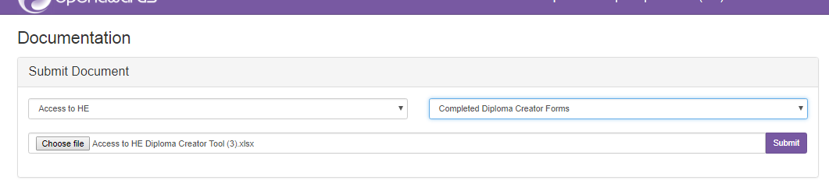
Click on Submit as above. You will be asked to confirm your submission.
If you have a query for us please continue to email ahed@openawards.org.uk

