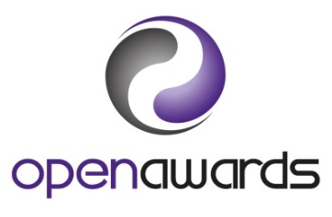
Functional Skills
Speaking, Listening and Communication
Assessment Internal Verification Panel Form

Date of Meeting:
Location of the meeting:
Cohorts covered by the panel:

No | Agenda | Notes | Actions
Present:
(As a minimum all assessors and Internal Verifier)
 | Apologies:
Matters arising from previous panel:
(where applicable)
Review and confirmation of results:
The panel should consider:
- Have the mark schemes and standards been consistently applied?
- Results in comparison to predicted learner performance
- Observation reports
- Application of standard in comparison with previous cohorts (where applicable)
Decisions must be made in accordance with the Speaking, Listening and Communication Assessment specification.
 | Any other business:

Present (add addition rows if required)
Name |  | Signature |  | Date
(Internal Verifier)

